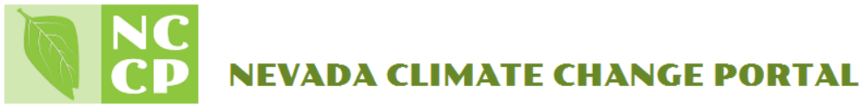
Atmospheric Barometer Experiment

Grade Level: 6-7
Objective: The objective of this experiment is to learn more about the function of our atmosphere and to create a barometer that will aid in the monitoring of atmospheric pressure. This experiment will also teach you how to determine the possible onset of atmospheric changes; such as the approach of a storm or a rainy day.
Project time: ongoing

Introduction:
Monitoring atmospheric pressure is important because our observations can aid in the predicament of weather patterns and global climate. Barometers are important for meteorologists, as they are used to predict our daily weather broadcasts.

Materials and Equipment:
- glass mayonnaise or canning jar
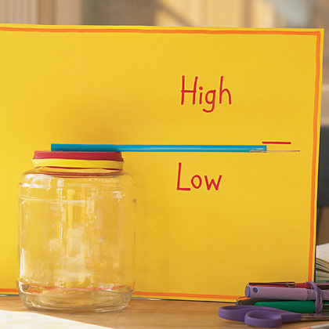
- balloon
- rubber band or tape
- straw
- toothpick
- glue/tape
- index card/piece of paper

Terms to define:
- wind speed
- wind direction
- humidity
- atmospheric pressure
- barometer

Research Questions:
- What happens with the air pressure outside if the barometer system changes?
- Can you predict how the barometer will react when a storm is approaching?
- Does the pressure inside the barometer system ever change? If so, when?
- How does this project relate to NevCAN data?

Experimental Procedure:
Part 1:
- Make sure your jar is clean and dry before stretching a piece of balloon over the top of the jar.
- Wrap a rubber band around the mouth of the jar, to keep the balloon from coming off.
- Glue a straw sideways from the center of the balloon to the end of the jar.
- Glue a toothpick to the end of the straw.
- On an index card write ‘High’ on top and ‘Low’ on the bottom near the toothpick's point.
- Monitor the fluctuations in the toothpick's point over the next few days.
- What's happening when it's pointing down or up?

Explanation:
Barometers keep track of air pressure. When air pressure is high (which means fair weather), the toothpick will point up because air will be pressing down on the balloon. When air pressure is low (which means stormy weather is coming), the toothpick will point down because air inside the jar will be pushing up against the balloon.

Part 2:
Select barometeric pressure data from the NCCP website and observe the readings for your chosen region/time frame. What is happening to the weather in this region?

